**DEPARTMENT OF COMPUTER SCIENCE AND APPLICATIONS**

**DEPARTMENTAL ACTIVITIES**

**SESSION 2024-25**

1. **The students of BCA V excel in Panjab University. Mukul Dhingra got Third Position in University and Manya got Fourth Position in the University.**

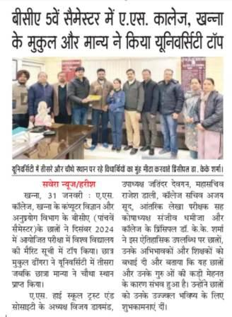

1. **Department of Computer Science and Applications of A.S. College, Khanna Organized Three Day Workshop on Python Programming in collaboration with Anu Infotech, Khanna from 19th September, 2024 to 21st September, 2024.**

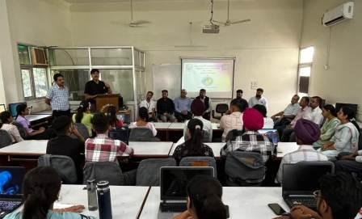

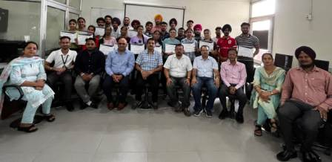

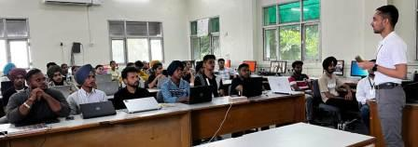

1. **Computer Science and Application Department of A.S.College, Khanna organized an extension lecture on Moral Values and Professional Ethics for BCA Students on 13-09-2024.**

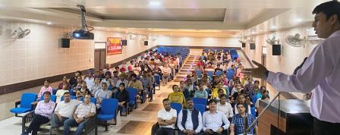

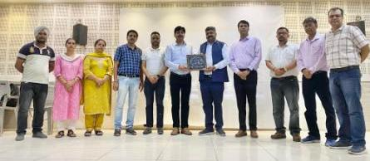

1. **The Computer Science and Application Department of A.S.College, Khanna celebrated International Programmers' Day to celebrate the positive changes that programmers are making in our lives.**

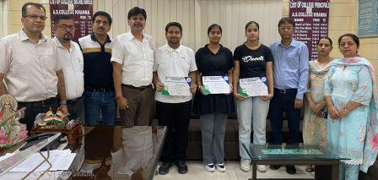

1. **Head of Department, Dr. Vivek Bhambri delivered an Expert Talk on Cyber Security on 28-12-2024 in 10 days NSS Camp organized by NSS unit of A.S.College, Khanna.**

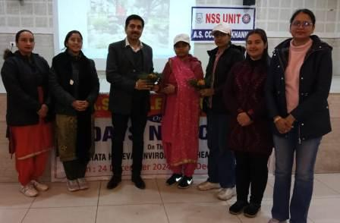

1. **Head of Department, Dr. Vivek Bhambri delivered an Expert Talk on Information Security and Data Mining on 05-01-2025 in 10 days NSS Camp organized by NSS unit of A.S.College of Education, Khanna.**

